git init = create the git history in this repository

git commit = save the changes for every stage of the process and create a bookmark you can go back to

git push =

git pull = to get the information from Github

I cloned from fbw26 the “lessons” repository

git remote -v

git pull = pull from your own github

git fetch = fetch from someone else’s github

echo "# github-test" >> README.md
this command will add this line to this file

new pull request = we want the master to pull my new update

first, I want to compare the changes##

git checkout -b logout = to create a new branch called “logout”

git checkout master = to switch to master

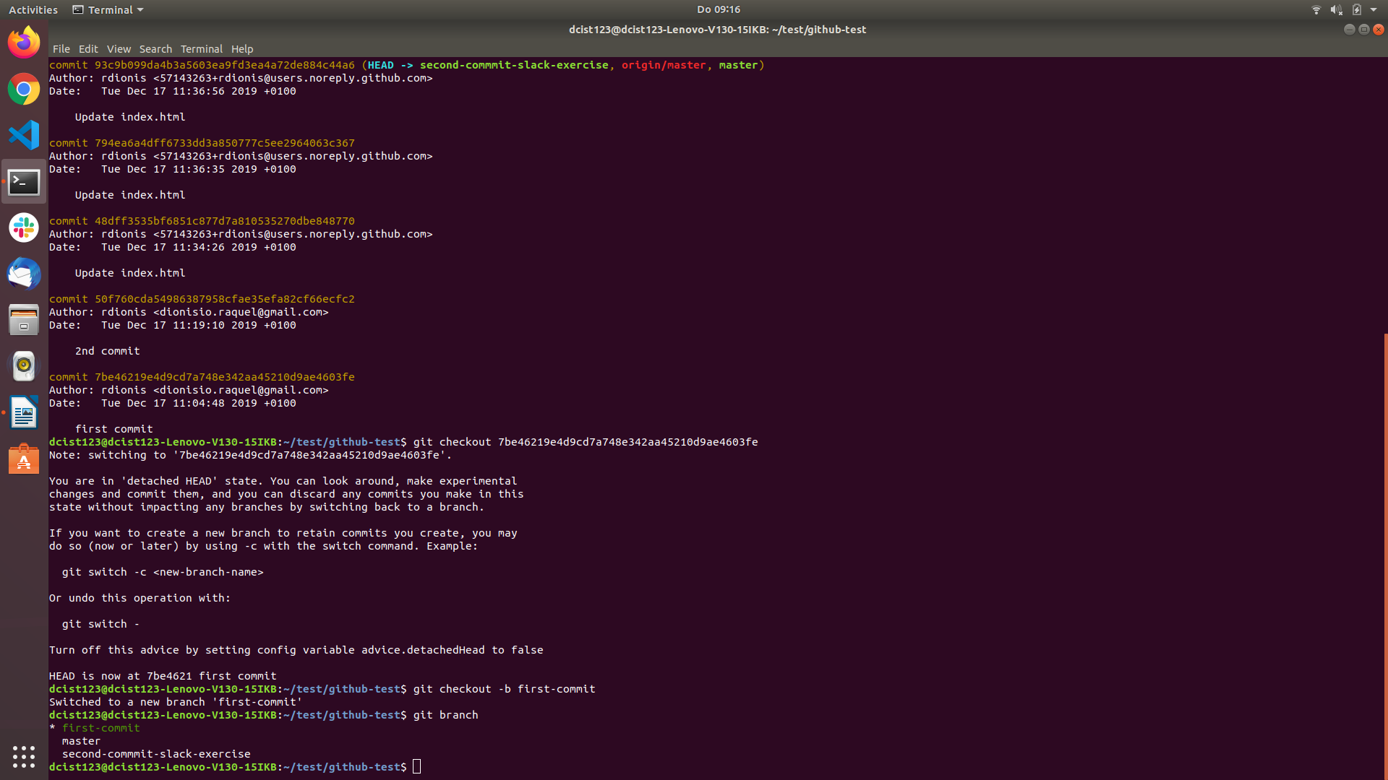
WWW (world wide web) – organisation that controls this hardware:

- protocols

Internet – hardware (the servers, etc)

